**Build Tables**

***Assignment:*** Follow the instructions below and write the SQL needed to complete each scenario. Use SQL Server Management Studio’s “Database Diagrams” tool to create your ERDs. Submit the SQL, explanations, and screen shots to Blackboard in one Word document.

If unsure about a datatype, consult with the MS SQL Server documentation listed at <https://docs.microsoft.com/en-us/sql/t-sql/data-types/data-types-transact-sql?view=sql-server-ver15>

*Scenario 1:*

1. Create the three tables below with the given datatype, primary keys and foreign keys. Include your SQL here.
2. Take a snippet of your ER Diagrams, it should look similar to the one from SQL Server below.

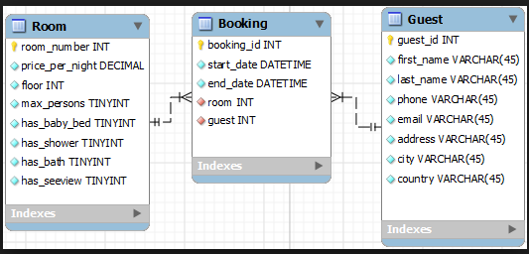

SQL Server ER

There is more on the next page

*Scenario 2:*

1. Create the three tables below with the correct datatype, primary keys and foreign keys. Include your SQL here.
2. Take a snippet of your ER diagrams, it should look similar to the SQL Server below.

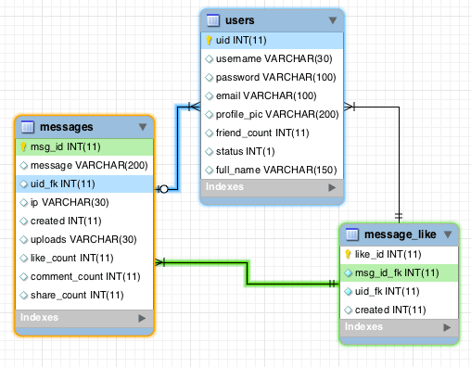

SQL Server ER

There is more on the next page

*Scenario 3:*

1. Create the two tables below with the correct datatype, primary keys and foreign keys. Include your SQL here.
2. Take a snippet of your ER diagrams, it should look similar to the SQL Server one below.

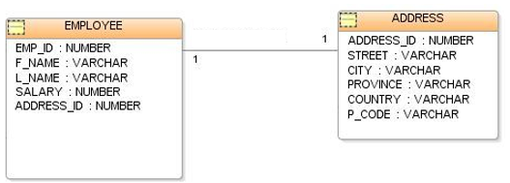

SQL Server ER

This is the last page